MLflow in Databricks is a tool used to track, manage, and organize Machine Learning experiments.
Think of it like a:
“Notebook + Scoreboard + History Tracker” for Machine Learning models.
Why MLflow Is Needed
When data scientists build models, they keep changing:
- Algorithms
- Parameters
- Datasets
- Training methods
Without tracking, they forget:
- Which model gave best accuracy
- What parameters were used
- Which version was deployed
- Who created the model
- When it was trained
MLflow solves this problem.
Simple Non-Coding Real-Life Example
Imagine a student preparing for exams.
The student tries different study methods:
Day | Study Method | Hours Studied | Result
Monday | Reading Notes | 2 hrs | 60%
Tuesday | Watching Videos | 3 hrs | 75%
Wednesday | Practice Questions | 4 hrs | 90%
Now after 1 month, the student wants to know:
- Which method worked best?
- How many hours gave best result?
- Which day performance improved?
Instead of remembering everything manually, the student keeps a notebook tracking all experiments.
That notebook is similar to MLflow.
In Machine Learning
Instead of study methods, we track:
Experiment | Algorithm | Accuracy
Run 1 | Logistic Regression | 82%
Run 2 | Random Forest | 91%
Run 3 | XGBoost | 95%
MLflow stores all this automatically.
What MLflow Tracks
MLflow mainly tracks:
1. Parameters
Example:
Learning Rate = 0.01
Algorithm = Random Forest
Epochs = 10
These are settings used while training.
2. Metrics
Performance numbers like:
Accuracy = 95%
Loss = 0.12
Precision = 91%
3. Model Files
MLflow saves trained models so they can be reused later.
4. Run History
Every experiment becomes a “Run”.
You can compare:
- Old runs
- New runs
- Best model
Simple Banking Example
Suppose a bank wants to detect fraud transactions.
Data scientist tries:
Run | Model | Accuracy
Run 1 | Logistic Regression | 80%
Run 2 | Random Forest | 89%
Run 3 | XGBoost | 94%
MLflow helps bank teams:
- Compare models
- Store best model
- Track changes
- Avoid confusion
What You See in MLflow Dashboard
Inside Databricks you see:
Run ID | Model | Accuracy | Time
101 | Logistic Regression | 82% | 2 mins
102 | Random Forest | 91% | 5 mins
This helps teams monitor experiments easily.
Main Uses of MLflow
Experiment Tracking
Track all model training runs.
Model Versioning
Store model versions like:
Fraud_Model_V1
Fraud_Model_V2
Fraud_Model_V3
Collaboration
Teams can see each other's experiments.
Reproducibility
You can recreate same model later.
Deployment Support
Deploy best model to production.
Very Simple One-Line Understanding
MLflow is like an “experiment diary” for Machine Learning projects.

Real-Time Companies Using MLflow
Many companies use tools like MLflow for:
- Fraud detection
- Recommendation systems
- Customer prediction
- Healthcare analytics
- Stock forecasting

Simple Serverless Databricks + MLflow Example
This version uses:
- Serverless notebook
- No cluster creation
- MLflow tracking
- Scheduled workflow
- Simple dataset
Step 1: Create Notebook
Go to:
- Workspace
- Create → Notebook
Notebook Name:
serverless_mlflow_demo
Language:
Python
For Compute select:
Serverless
Step 2: Create Dataset Inside Notebook
No upload required.
Paste this first cell:
import pandas as pd
data = {
"Age": [22,25,27,29,31,35,38,41,45,48],
"Salary": [25000,32000,35000,42000,52000,58000,61000,65000,72000,79000],
"Purchased": [0,0,0,0,1,1,1,1,1,1]
}
df = pd.DataFrame(data)
display(df)
Step 3: MLflow Training Notebook
Paste this in second cell.
# Install libraries
%pip install mlflow scikit-learn
import mlflow
import mlflow.sklearn
from sklearn.model_selection import train_test_split
from sklearn.linear_model import LogisticRegression
from sklearn.metrics import accuracy_score
# Features and target
X = df[['Age', 'Salary']]
y = df['Purchased']
# Split data
X_train, X_test, y_train, y_test = train_test_split(
X, y, test_size=0.2, random_state=42
)
# Start MLflow experiment tracking
with mlflow.start_run():
# Create model
model = LogisticRegression()
# Train model
model.fit(X_train, y_train)
# Predict
y_pred = model.predict(X_test)
# Accuracy
accuracy = accuracy_score(y_test, y_pred)
print("Model Accuracy:", accuracy)
# Log parameters
mlflow.log_param("model_name", "LogisticRegression")
# Log metrics
mlflow.log_metric("accuracy", accuracy)
# Log model
mlflow.sklearn.log_model(model, "purchase_prediction_model")
print("Run logged in MLflow successfully")
Step 4: Run Notebook
Click:
Run All
Expected output:
Model Accuracy: 1.0
Run logged in MLflow successfully
Step 5: Review MLflow Dashboard
In notebook right sidebar:
Click:
Experiments
You can now see:
- Run ID
- Accuracy
- Parameters
- Model artifact
- Execution duration
This is the MLflow tracking dashboard.
Step 6: Create Workflow Job (Serverless)
Go to:
Workflows → Create Job
Configure:
Job Name
ServerlessMLflowJob
Task Type
Notebook
Select notebook:
serverless_mlflow_demo
IMPORTANT (Serverless Setting)
Under Compute choose:
Serverless
NO cluster creation required.
Click:
Create
Step 7: Schedule Notebook
Inside Job:
Click:
Add Trigger
Choose:
Scheduled
Example:
- Every 1 hour
- Daily at 9 AM
Save.
Now notebook runs automatically using Serverless Compute.
Step 8: Track Multiple Runs
Every scheduled execution creates:
- New MLflow run
- New metrics
- New model version
- Execution logs
You can compare runs in MLflow UI.
Real-Time Industry Flow
Notebook
↓
Serverless Compute
↓
ML Model Training
↓
MLflow Tracking
↓
Workflow Scheduling
↓
Automated Runs

Advantages of Serverless
- No cluster management
- Faster startup
- Lower operational work
- Auto scaling
- Easy scheduling
- Pay only when used

Create your first workflow with Lakeflow Jobs
Lakeflow Jobs to orchestrate tasks to read and process a sample dataset.
- Create a new notebook and add code to retrieve a sample dataset containing popular baby names by year.
- Save the sample dataset to Unity Catalog.
- Create a new notebook and add code to read the dataset from Unity Catalog, filter it by year, and display the results.
- Create a new job and configure two tasks using the notebooks.
- Run the job and view the results.
Requirements
If your workspace is Unity Catalog-enabled and Serverless Jobs is enabled, by default, the job runs on Serverless compute. You do not need cluster creation permission to run your job with Serverless compute.
Otherwise, you must have cluster creation permission to create job compute or permissions to all-purpose compute resources.
Create notebooks
The following steps create two notebooks to run in this workflow.
Retrieve and save data
To create a notebook that retrieves the sample dataset and saves it to Unity Catalog:
- Click New in the sidebar, then click Notebook. Databricks creates and opens a new, blank notebook in your default folder. The default language is the language you most recently used, and the notebook is automatically attached to the compute resource that you most recently used.
- (Optional) Rename the notebook Retrieve name data.
- If necessary, change the default language to Python.
- Copy the following Python code and paste it into the first cell of the notebook.
Python
import requests
response = requests.get('https://health.data.ny.gov/api/views/jxy9-yhdk/rows.csv')
csvfile = response.content.decode('utf-8')
dbutils.fs.put("/Volumes/main/default/my-volume/babynames.csv", csvfile, True)
Read and display filtered data
To create a notebook that filters and displays your data:
- Click New in the sidebar, then click Notebook.
- (Optional) Rename the notebook Filter name data.
- The following Python code reads the data you saved in the previous step and creates a table. It also creates a widget that you can use to filter the data in the table.
Python
babynames = spark.read.format("csv").option("header", "true").option("inferSchema", "true").load("/Volumes/main/default/my-volume/babynames.csv")
babynames.createOrReplaceTempView("babynames_table")
years = spark.sql("select distinct(Year) from babynames_table").toPandas()['Year'].tolist()
years.sort()
dbutils.widgets.dropdown("year", "2014", [str(x) for x in years])
display(babynames.filter(babynames.Year == dbutils.widgets.get("year")))
Create a job
The job you are creating consists of two tasks.
To create the first task:
- In your workspace, click Jobs & Pipelines in the sidebar.
- Click Create, then Job.
- Click the Notebook tile to configure the first task. If the Notebook tile is not available, click Add another task type and search for Notebook.
- (Optional) Replace the name of the job, which defaults to New Job <date-time>, with your job name.
- In the Task name field, enter a name for the task; for example, retrieve-baby-names.
- If necessary, select Notebook from the Type drop-down menu.
- In the Source drop-down menu, select Workspace, which allows you to use a notebook you saved previously.
- For Path, use the file browser to find the first notebook you created, click the notebook name, and click Confirm.
- Click Create task. A notification appears in the upper-right corner of the screen.
To create the second task:
- Click + Add task > Notebook.
- In the Task name field, enter a name for the task; for example, filter-baby-names.
- For Path, use the file browser to find the second notebook you created, click the notebook name, and click Confirm.
- Click Add under Parameters. In the Key field, enter year. In the Value field, enter 2014.
- Click Create task.
Run the job
To run the job immediately, click in the upper right corner.
View run details
- Click the Runs tab and click the link in the Start time column to open the run that you want to view.
- Click click either task to see the output and details. For example, click the filter-baby-names task to view the output and run details for the filter task:
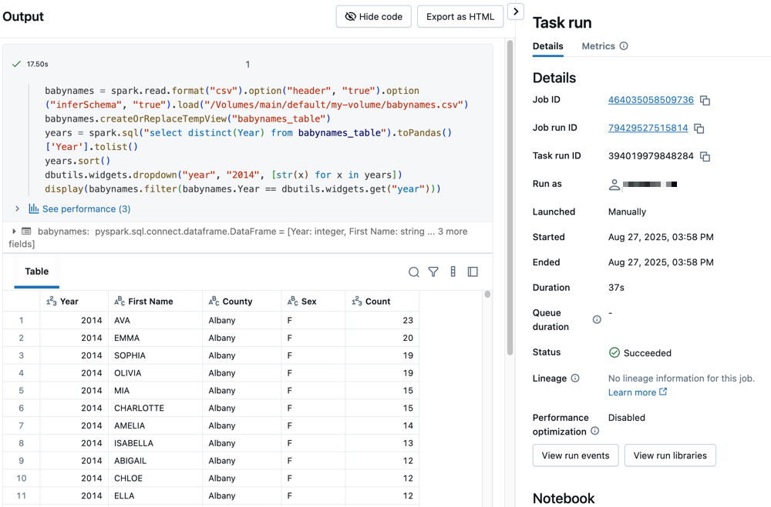
Run with different parameters
To re-run the job and filter baby names for a different year:
- Click  next to Run now and select Run now with different settings.
- In the Value field, enter 2015.
- Click Run.

